**Arduino UNO**

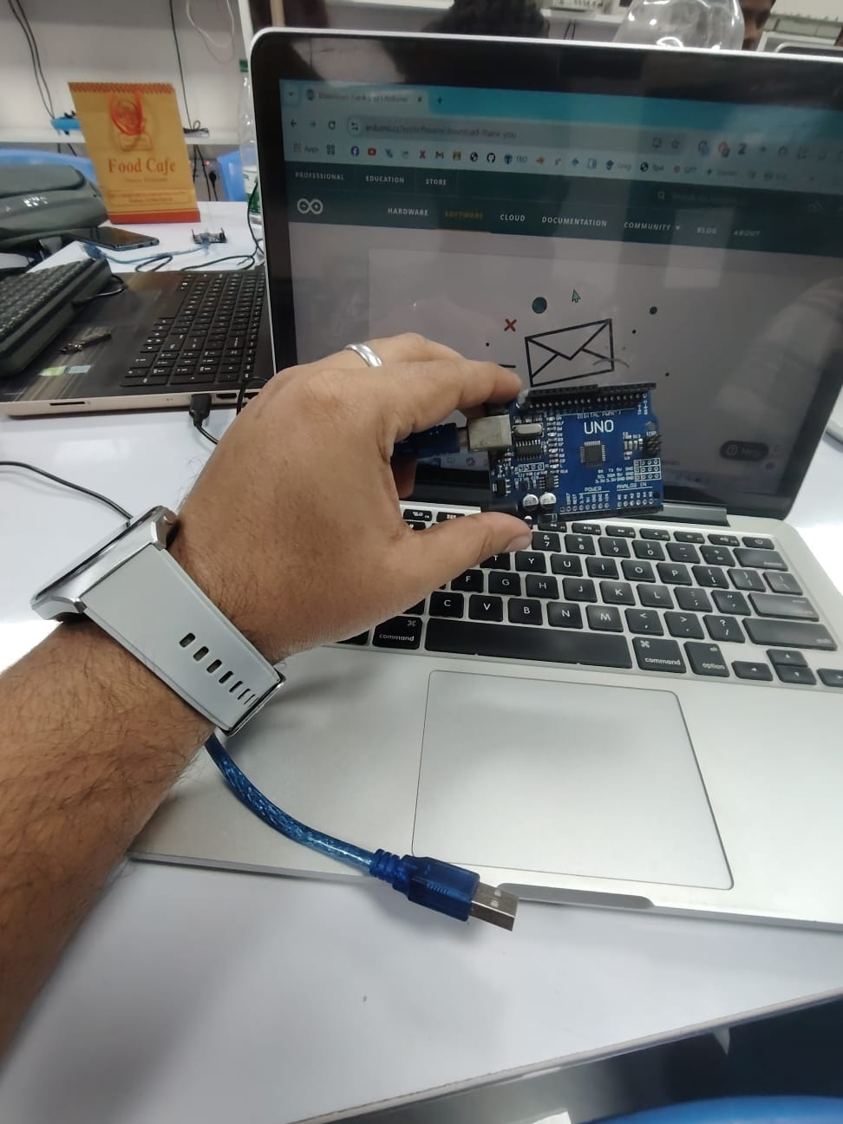

**Arduino Project: Blinking LED Tutorial**

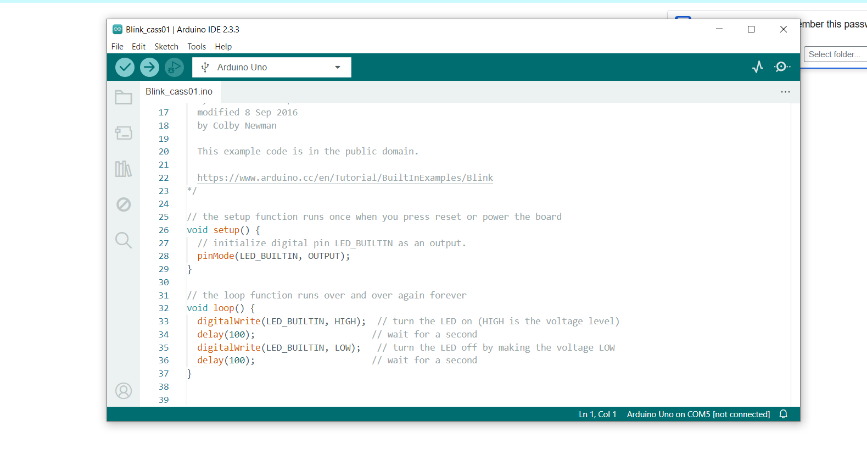Arduino sketch that demonstrates basic digital I/O and timing control. It initializes the built-in LED pin as an output and then enters a loop. Within this loop, the LED is turned on, held for one second, then turned off and held for another second. This cycle repeats continuously, resulting in a blinking LED at a one-second interval. This simple project is often used as a starting point for learning Arduino programming, showcasing the core concepts of setting pin modes, controlling digital outputs, and using delays.